SORTING ALGORITHMS
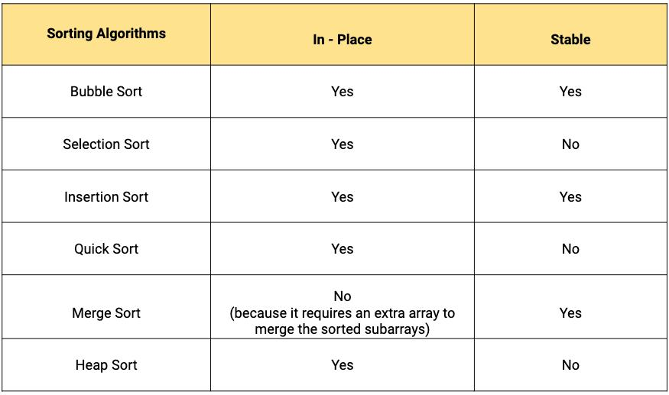
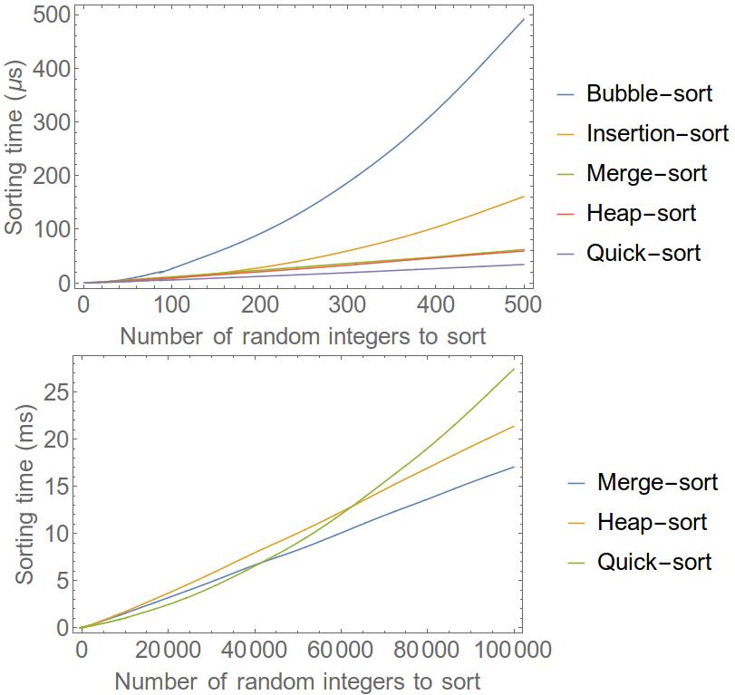
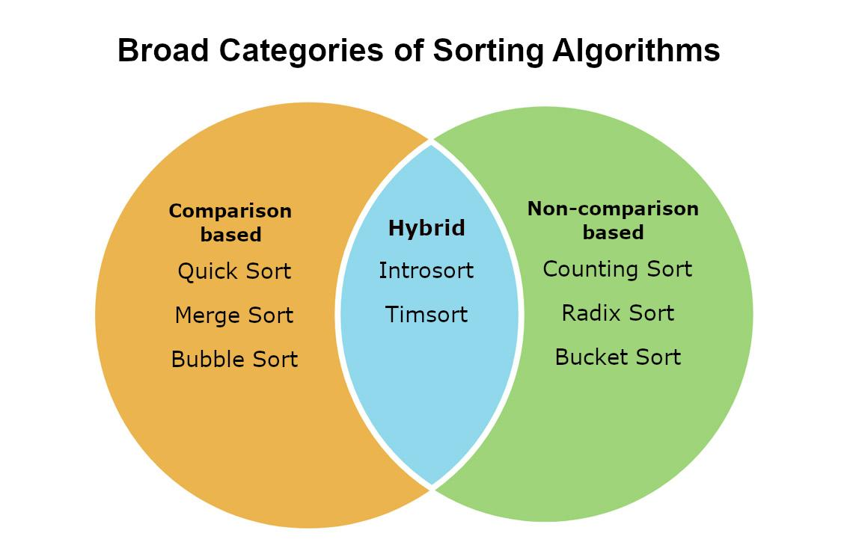
6
✅ Definition
Sorting is the process of arranging elements in a specific order (ascending/descending).

🎯 Importance
- Enables Binary Search
- Improves data processing
- Used in databases and analytics

🔷 1. COMPARISON-BASED SORTING
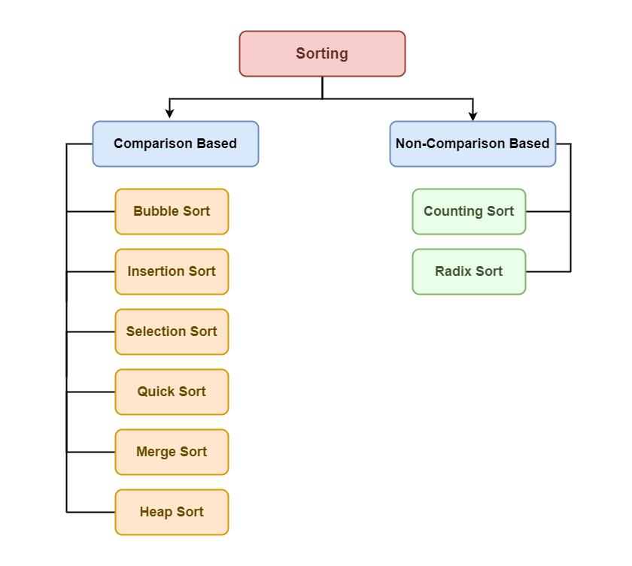
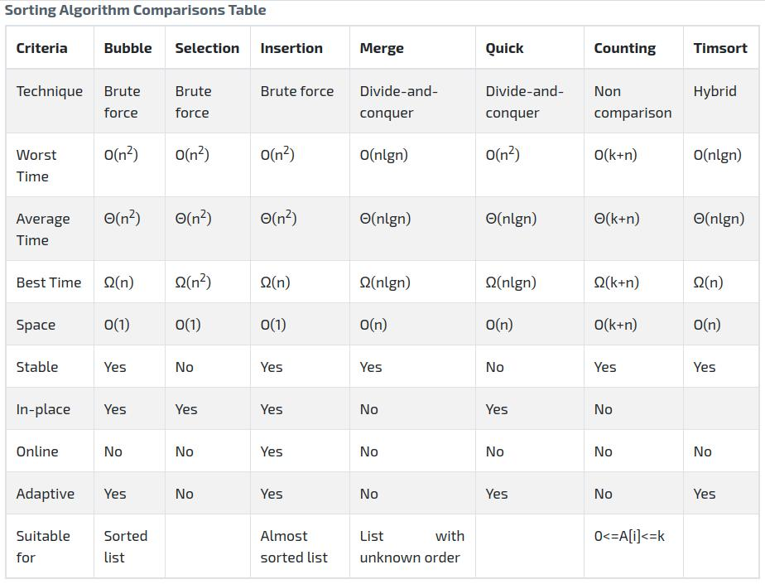
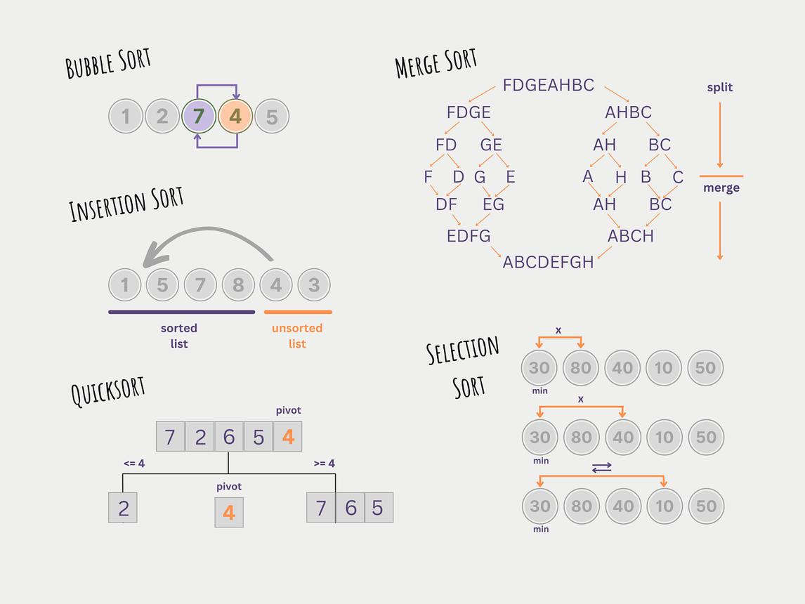
5

🔹 Selection Sort
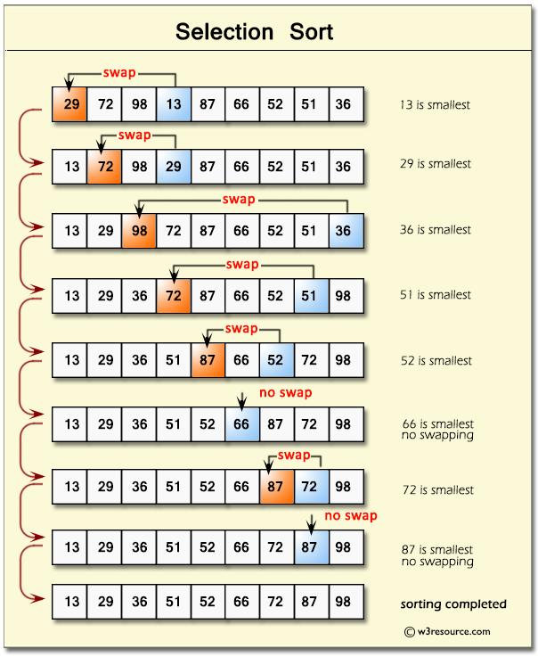
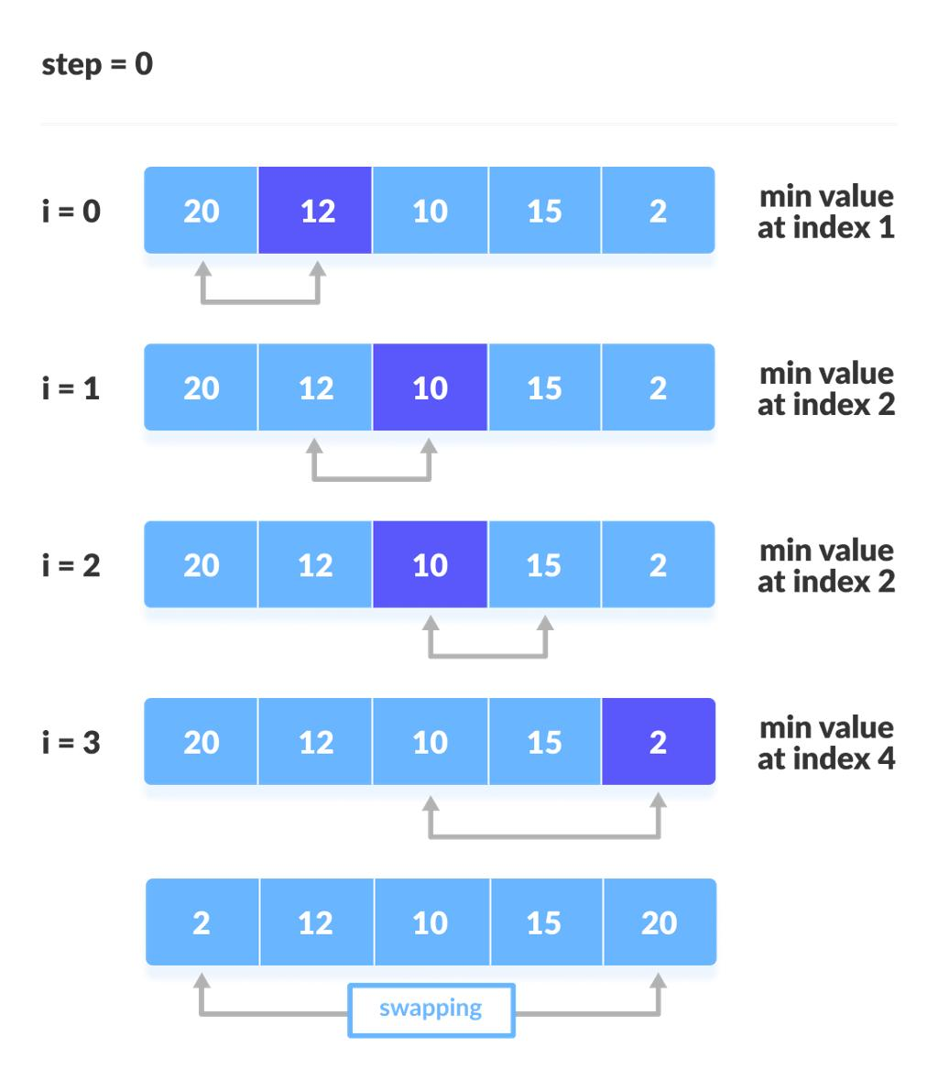
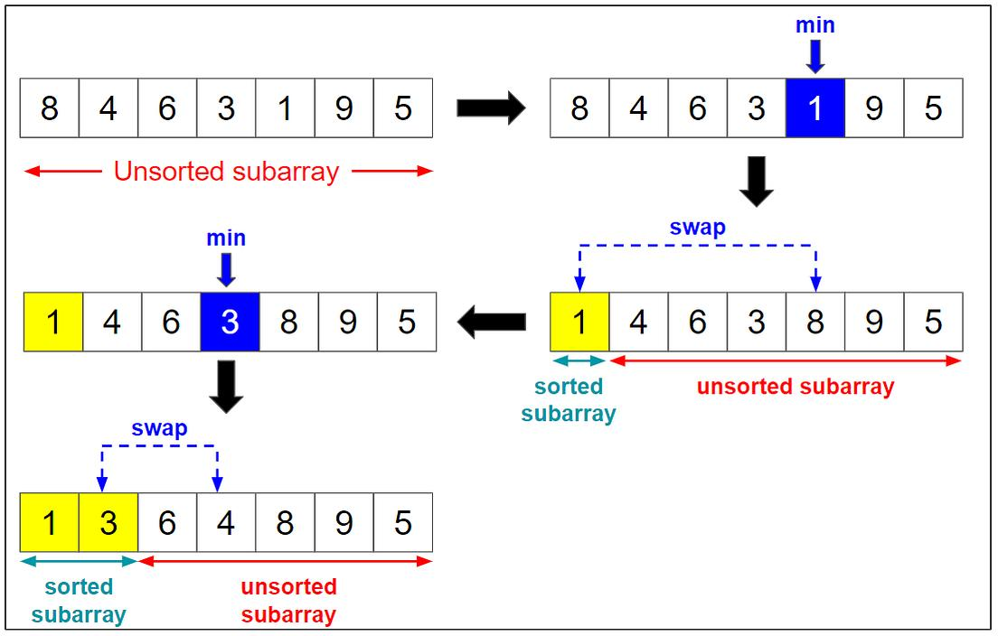
7
Definition: Select minimum and place correctly
Algorithm Idea:
Find min → swap
TC: O(n²)
SC: O(1)
Use Case: Small data
Pros: Simple, fewer swaps
Cons: Always slow
With vs Without: No improvement

🔹 Bubble Sort
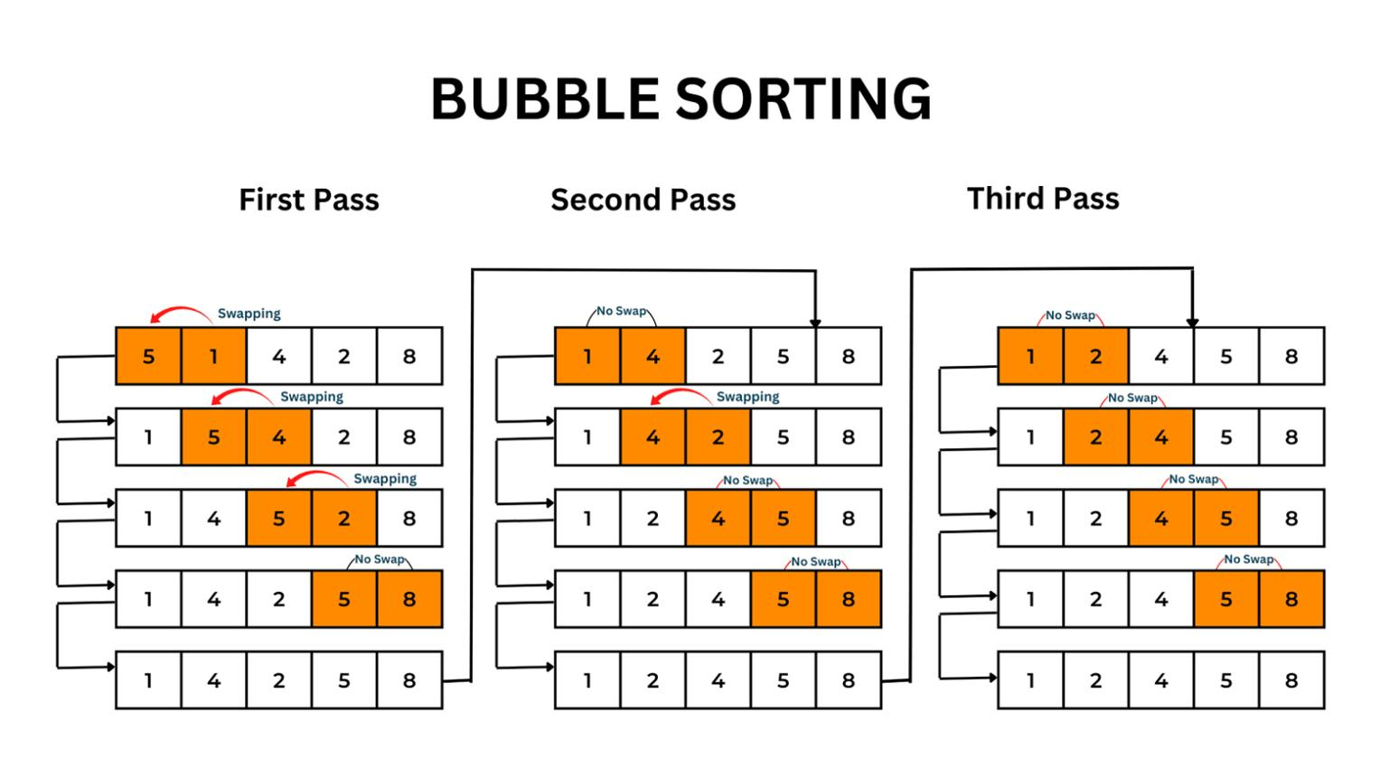
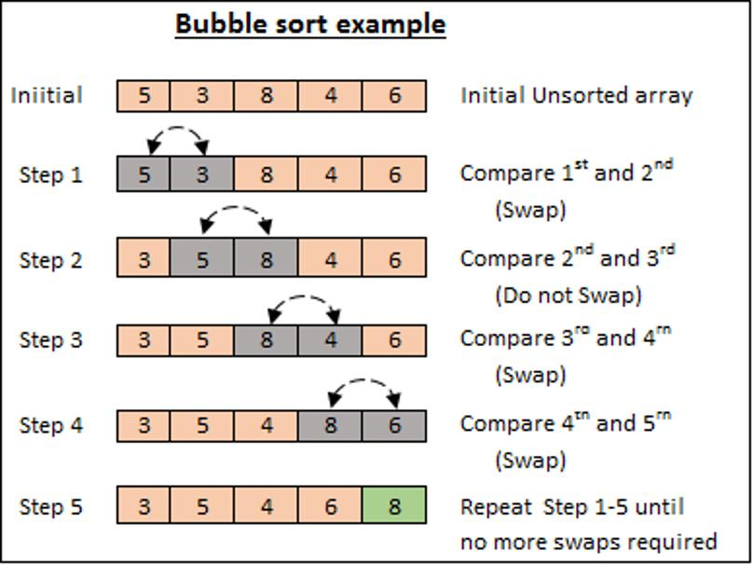
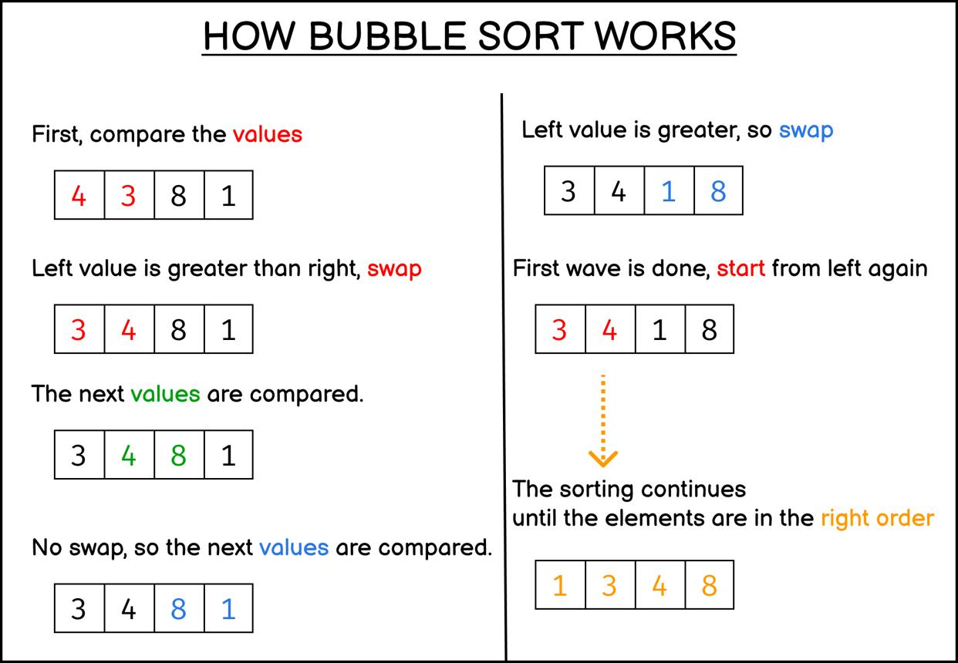
6
Definition: Swap adjacent elements
TC: O(n) best, O(n²) worst
SC: O(1)
Use Case: Educational
Pros: Stable, simple
Cons: Very slow
With vs Without:
- Sorted → fast
- Unsorted → slow

🔹 Insertion Sort
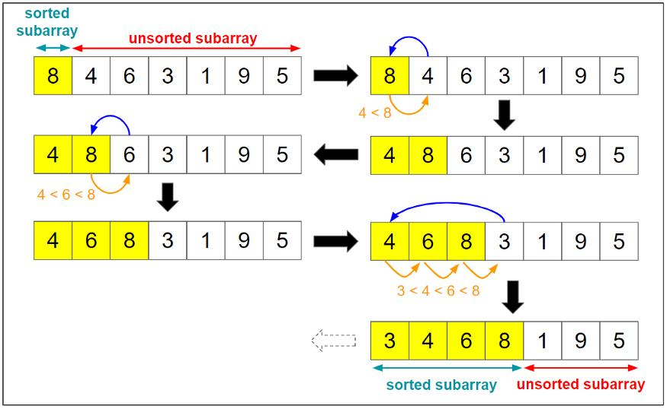
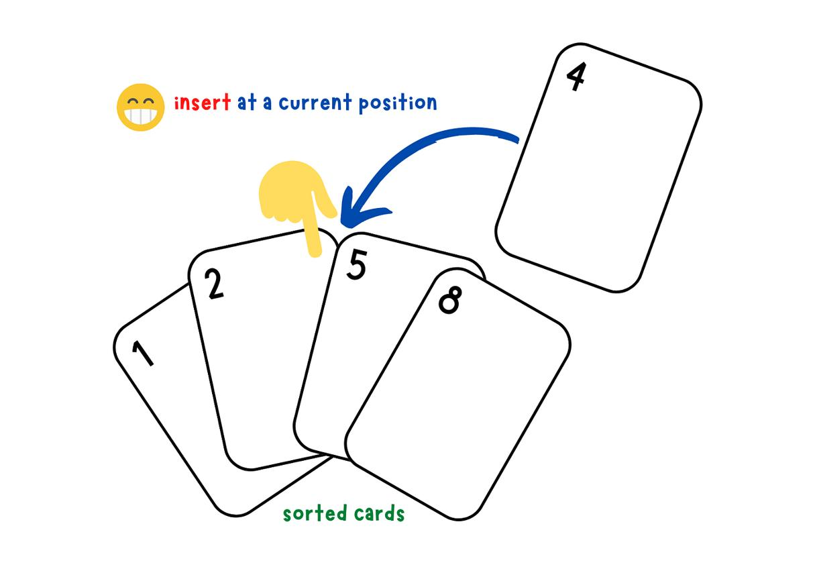
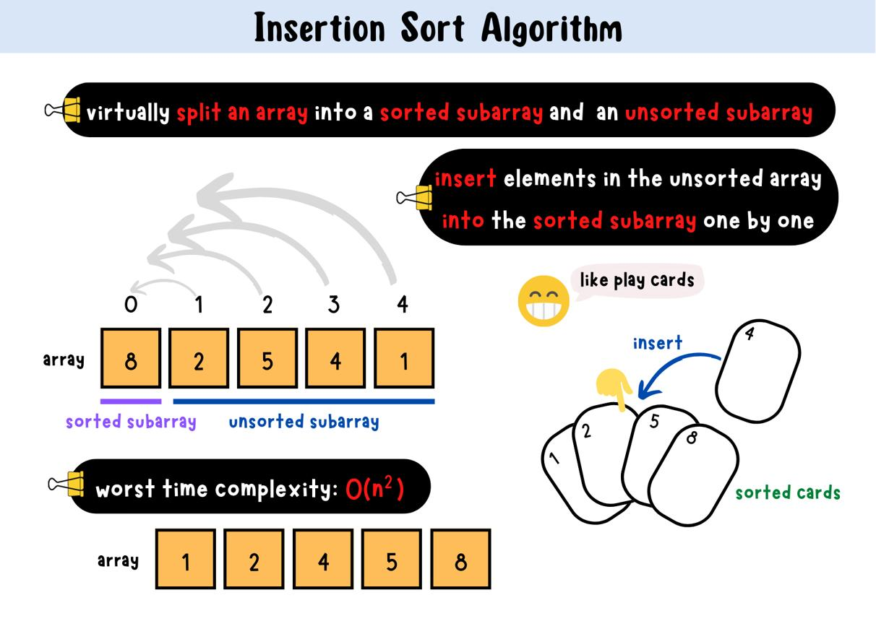
6
Definition: Insert into sorted part
TC: O(n) best, O(n²) worst
SC: O(1)
Use Case: Nearly sorted
Pros: Efficient for small data
Cons: Slow for large

🔹 Merge Sort
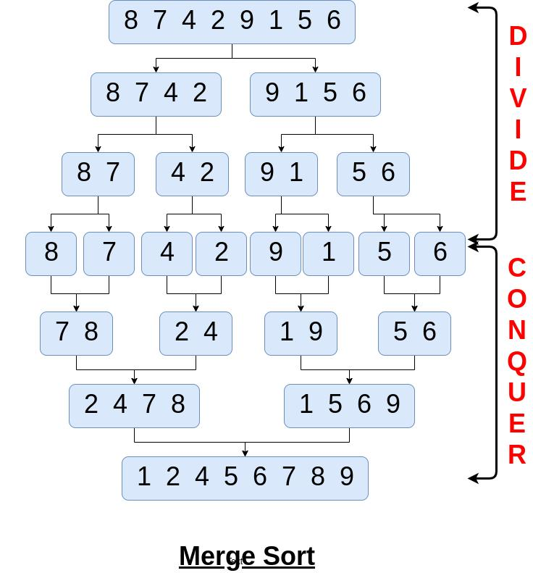
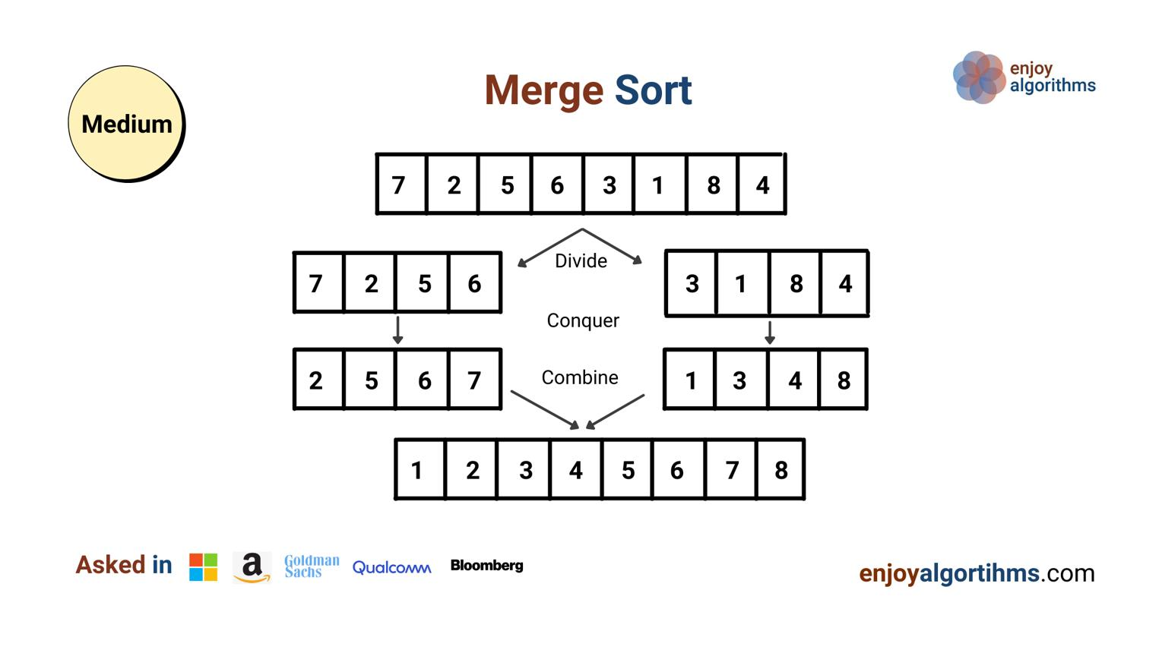
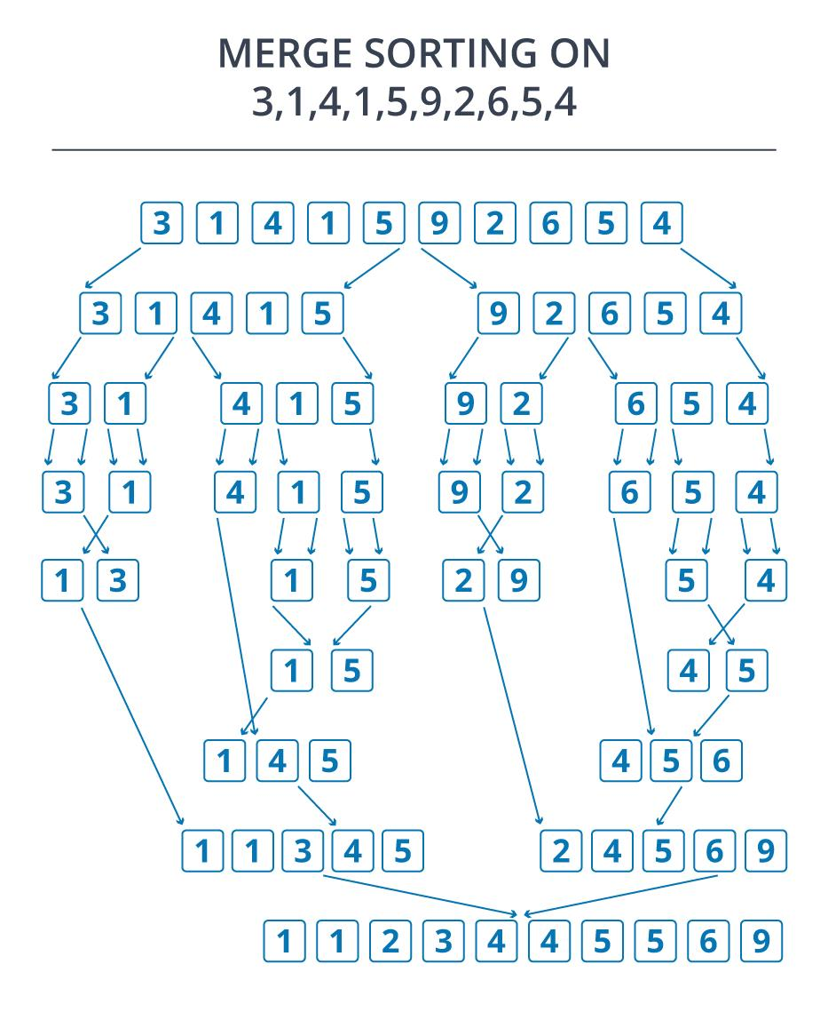
6
Definition: Divide & merge
TC: O(n log n)
SC: O(n)
Use Case: Large data
Pros: Stable, predictable
Cons: Extra memory

🔹 Quick Sort
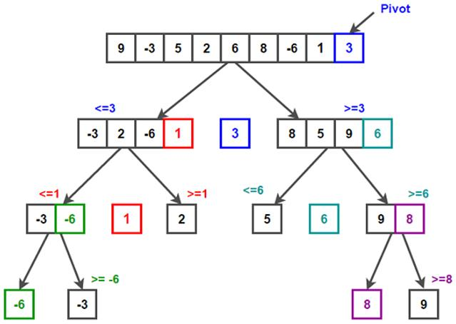
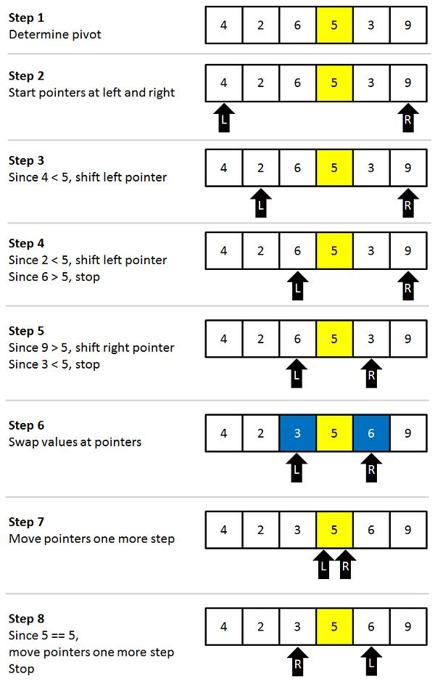
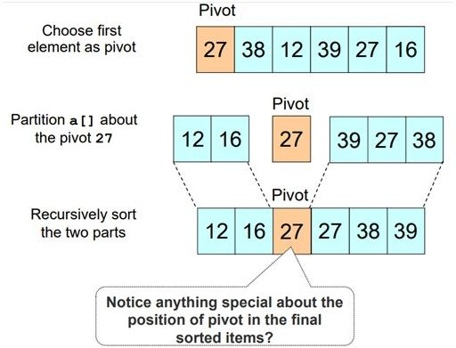
6
Definition: Partition by pivot
TC: Avg O(n log n), Worst O(n²)
SC: O(log n)
Use Case: General fast sorting
Pros: Fast, in-place
Cons: Worst-case slow

🔹 Heap Sort
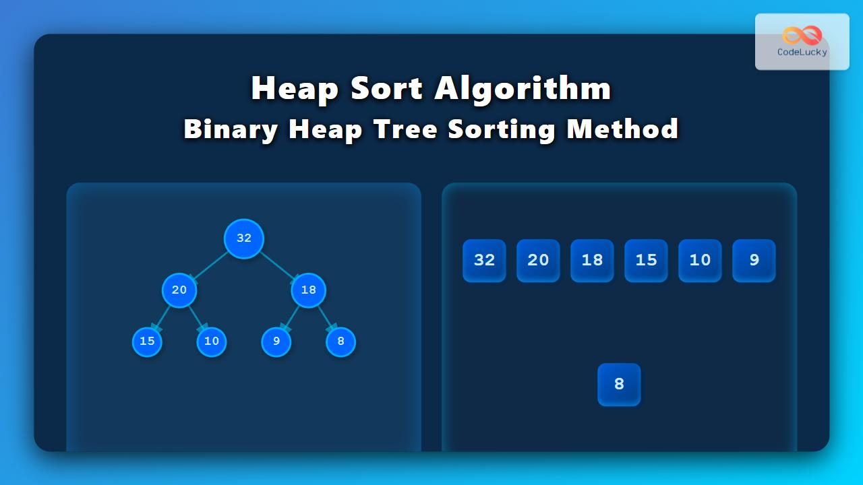
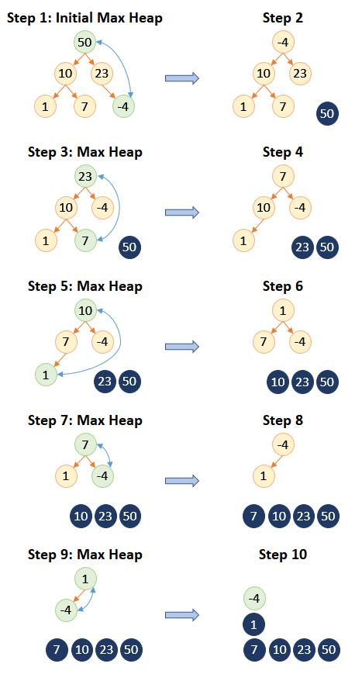
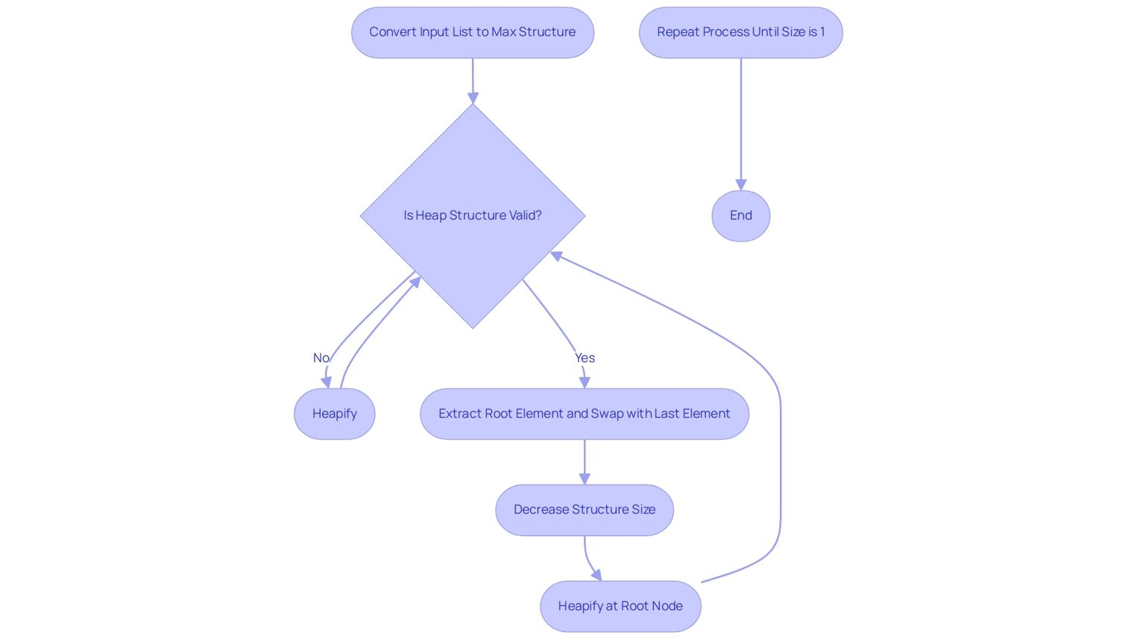
6
Definition: Uses heap
TC: O(n log n)
SC: O(1)
Use Case: Memory constrained
Pros: No extra space
Cons: Not stable

🔹 Cycle Sort
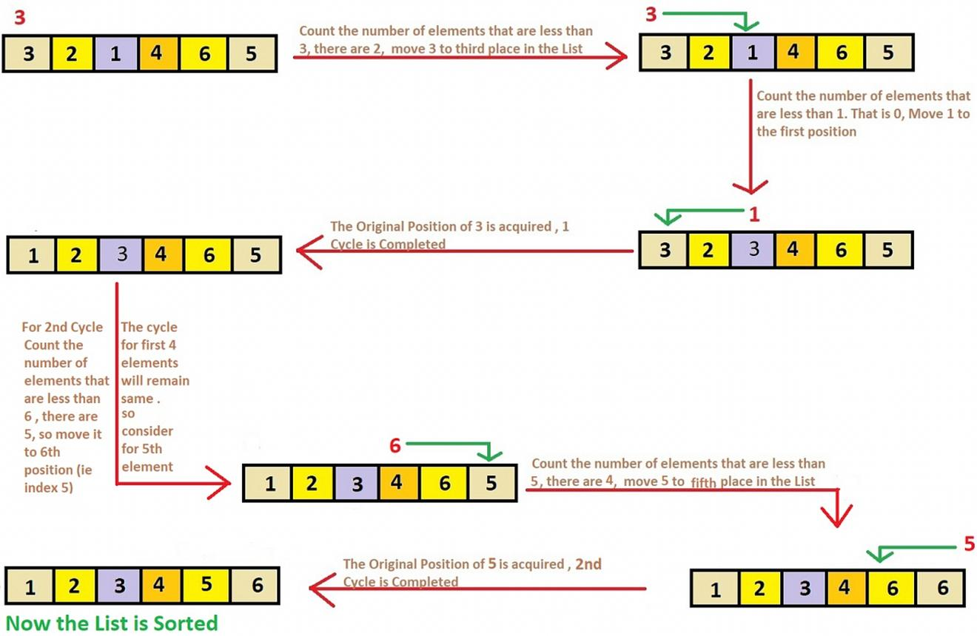
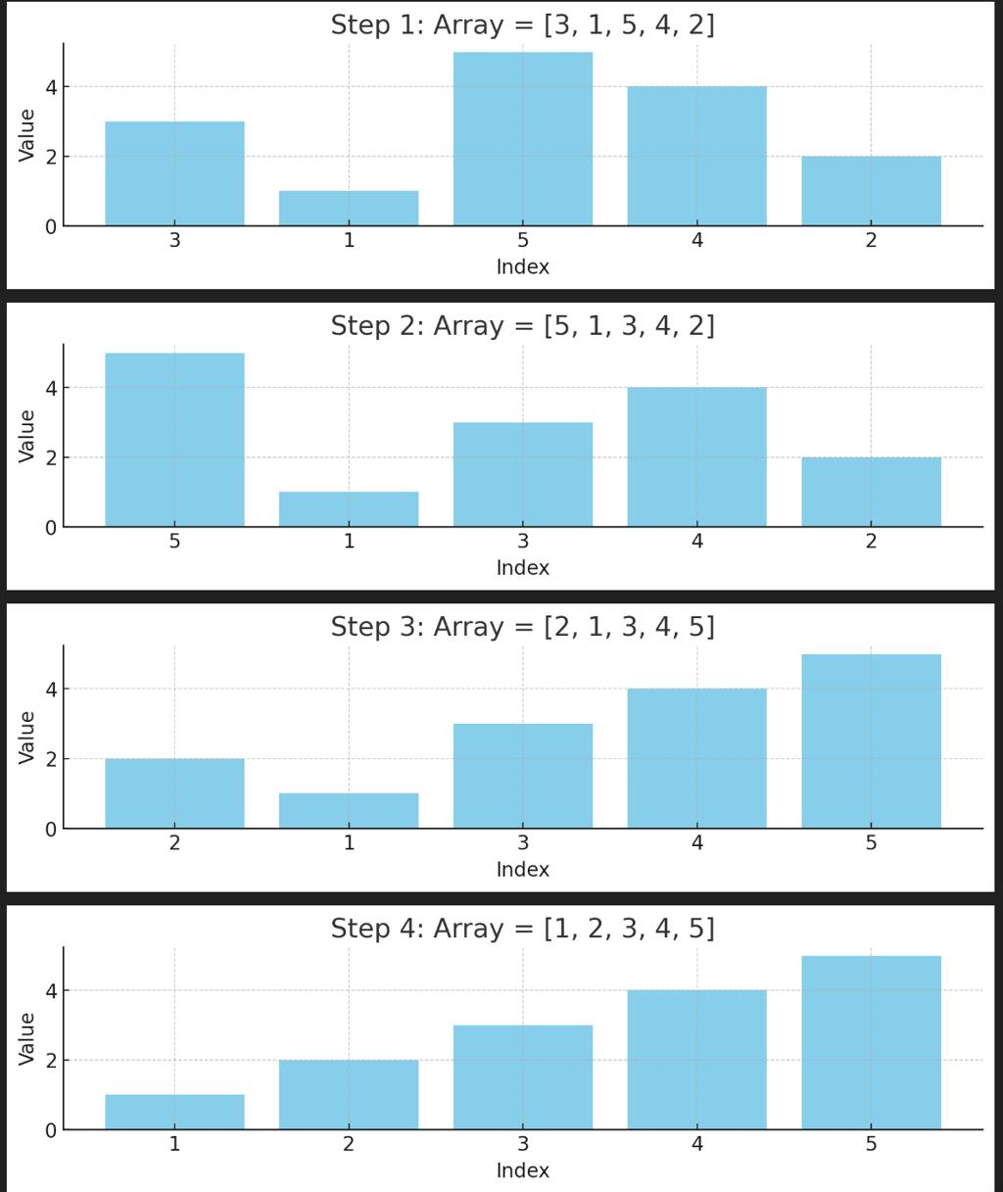
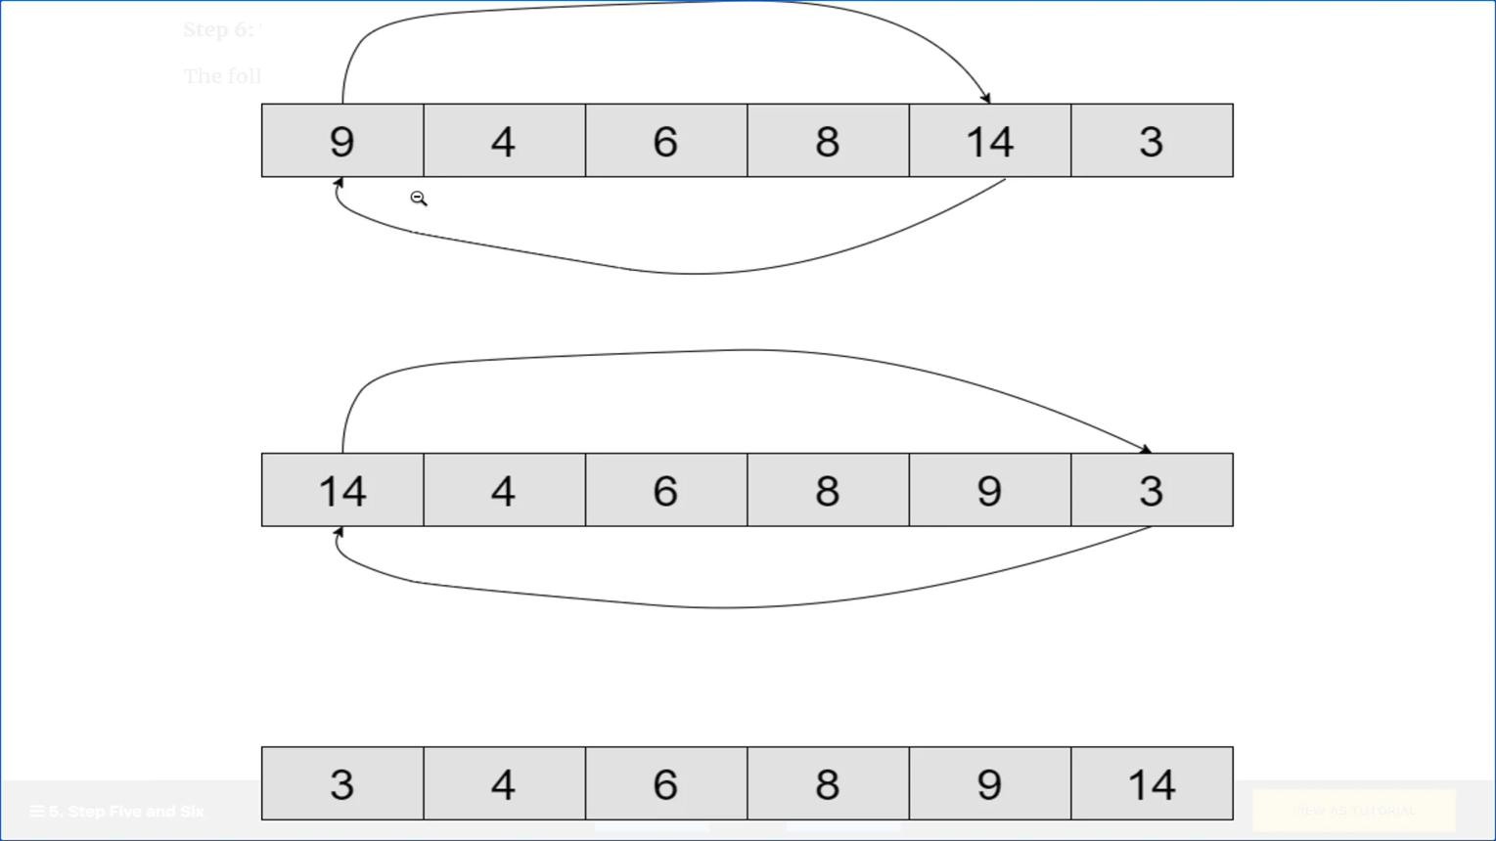
5
Definition: Minimizes writes
TC: O(n²)
SC: O(1)
Use Case: Write-limited memory

🔹 3-Way Merge Sort
Definition: Divide into 3 parts
TC: O(n log n)
SC: O(n)

🔷 2. NON-COMPARISON SORTING

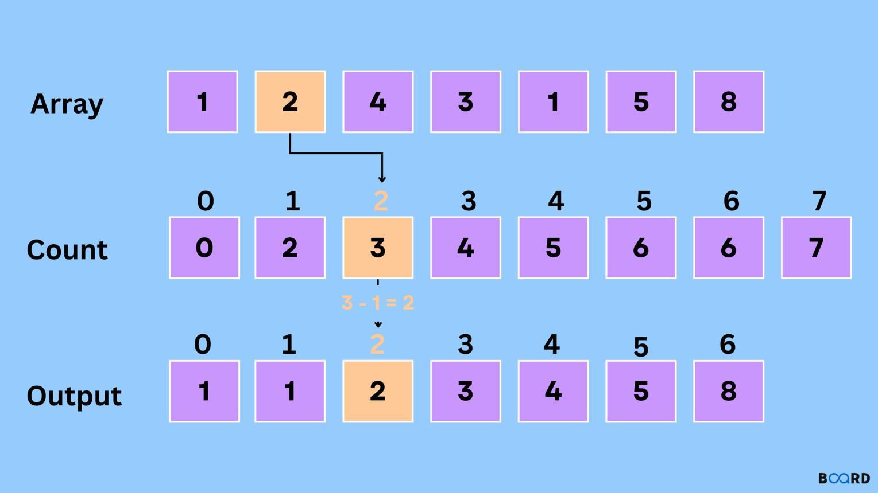
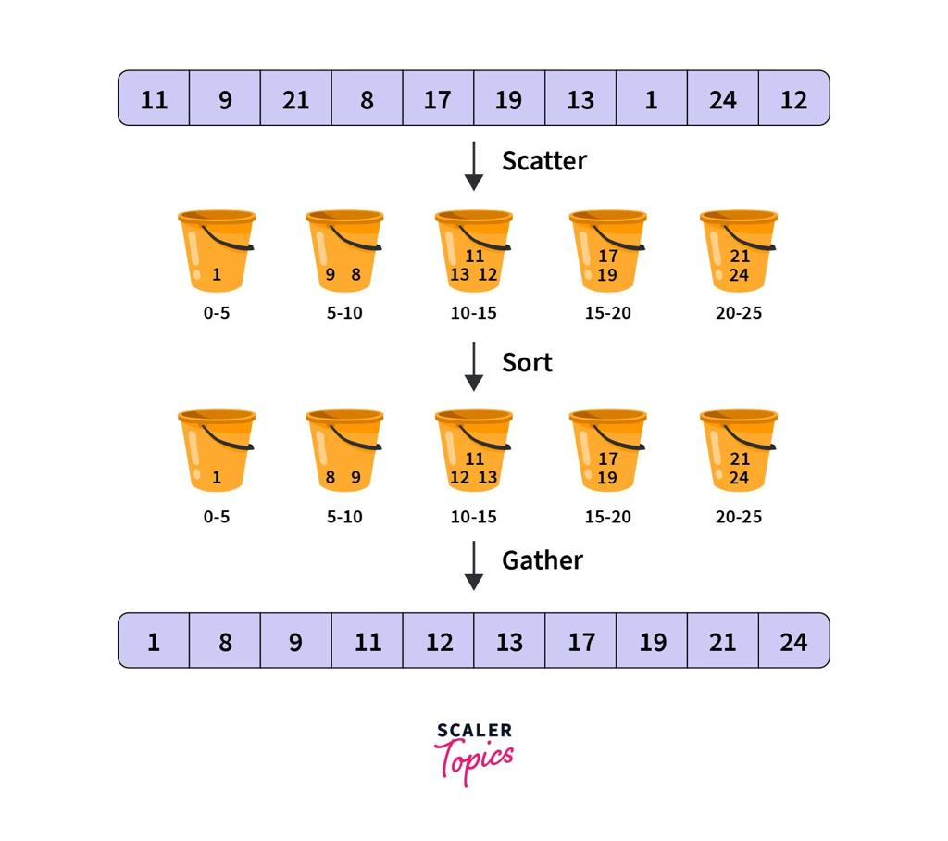
6

🔹 Counting Sort
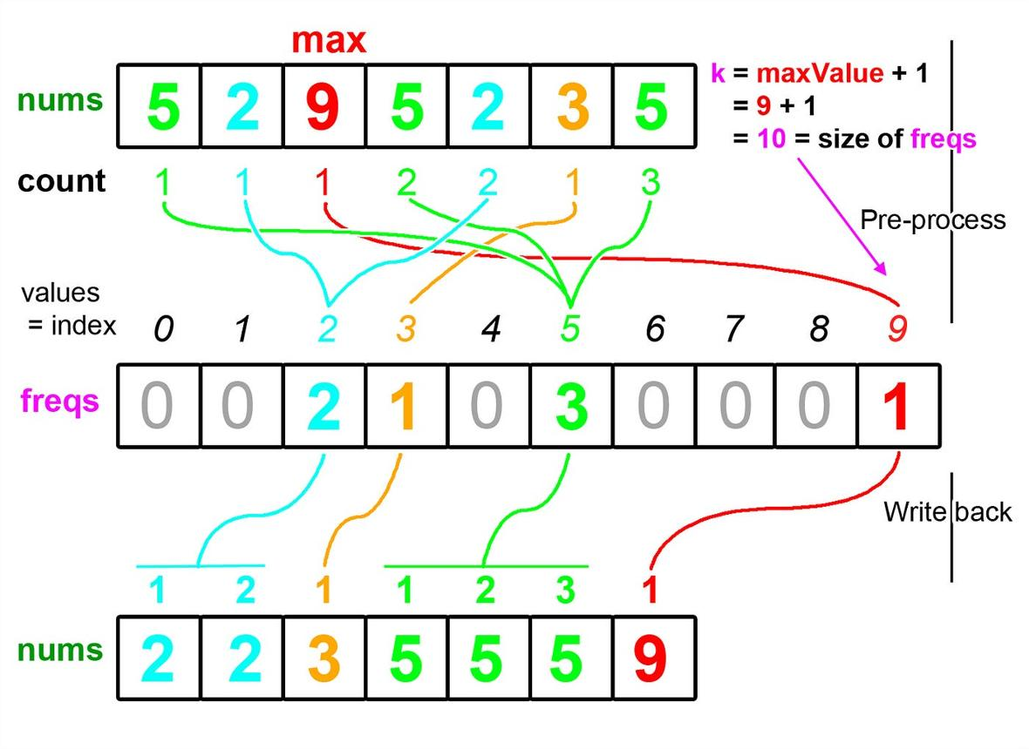
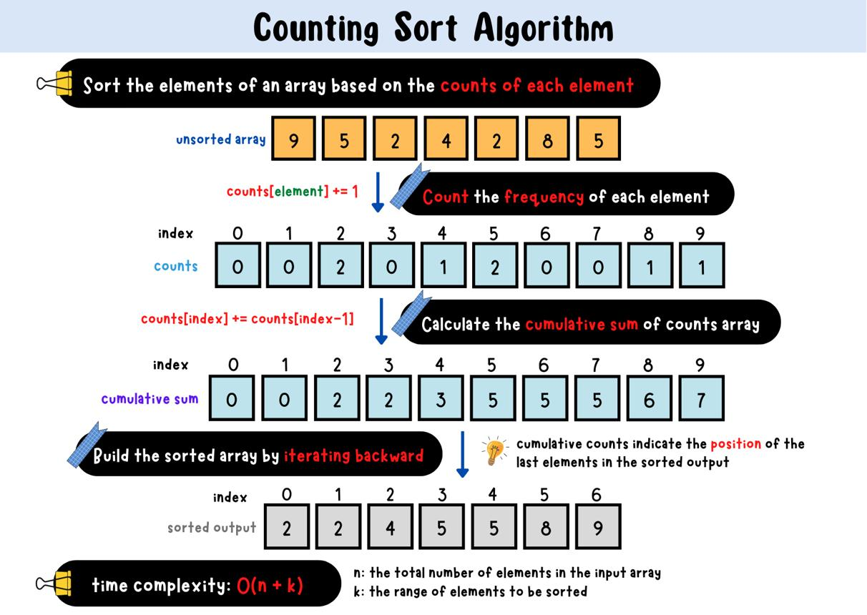
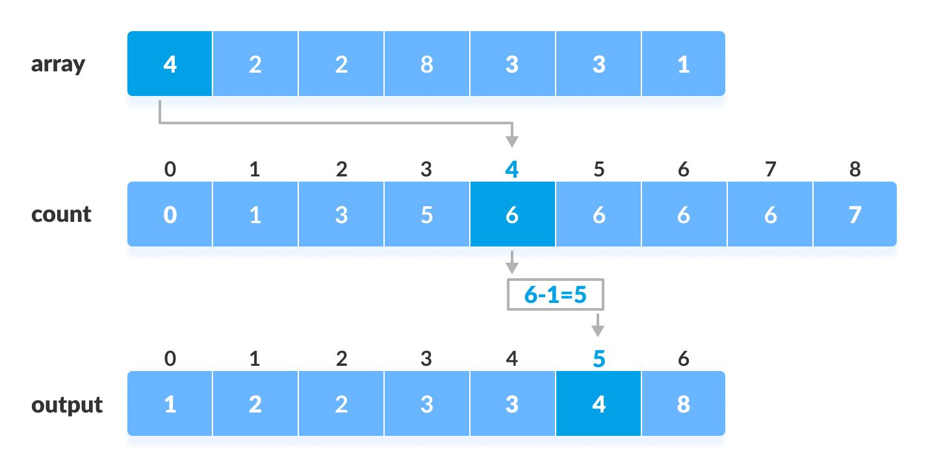
6
TC: O(n + k)
SC: O(k)
Pros: Very fast
Cons: Limited range

🔹 Radix Sort
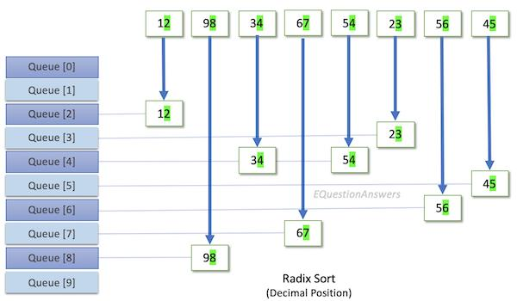
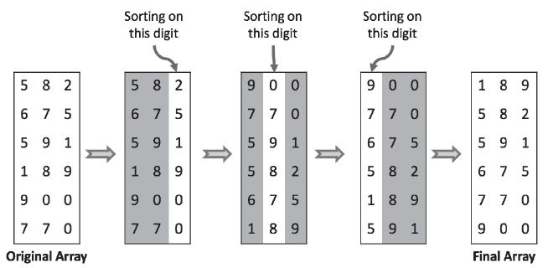
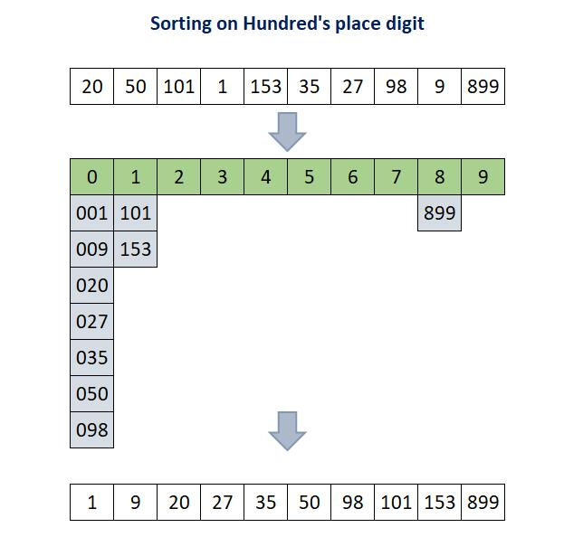
6
TC: O(nk)
SC: O(n + k)
Pros: Faster than comparison
Cons: Needs stable sort

🔹 Bucket Sort

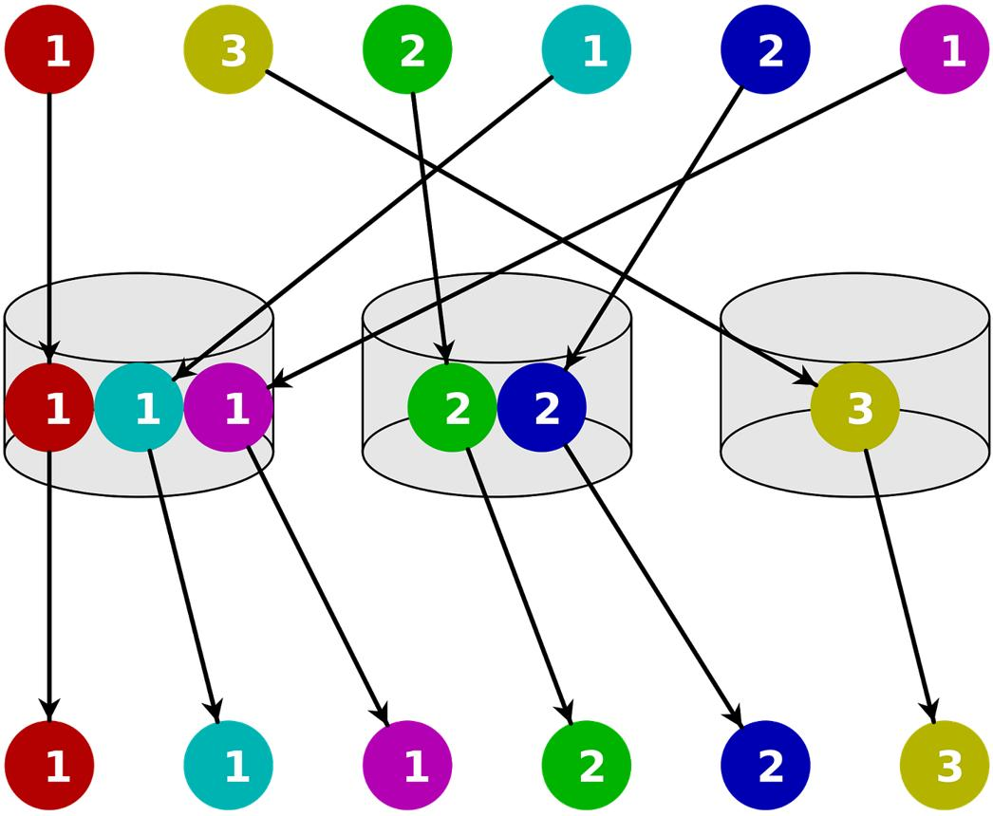
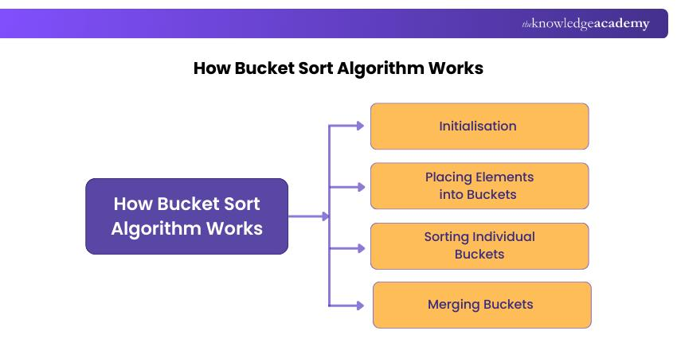
6
TC: Best O(n), Worst O(n²)
SC: O(n)

🔹 Pigeonhole Sort
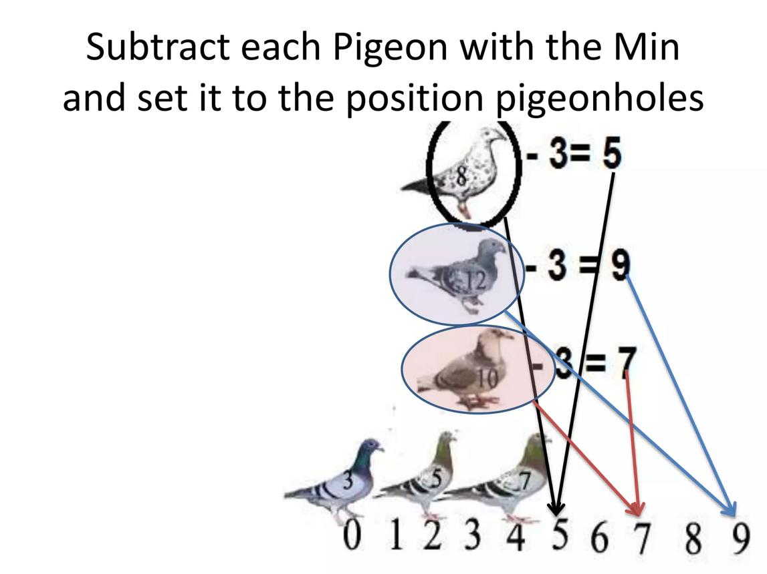
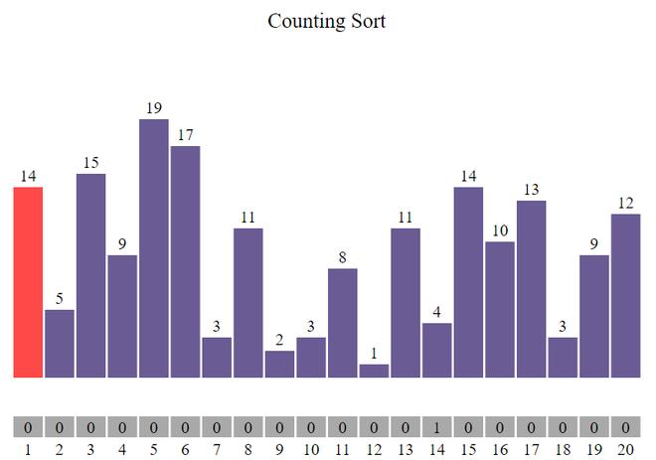
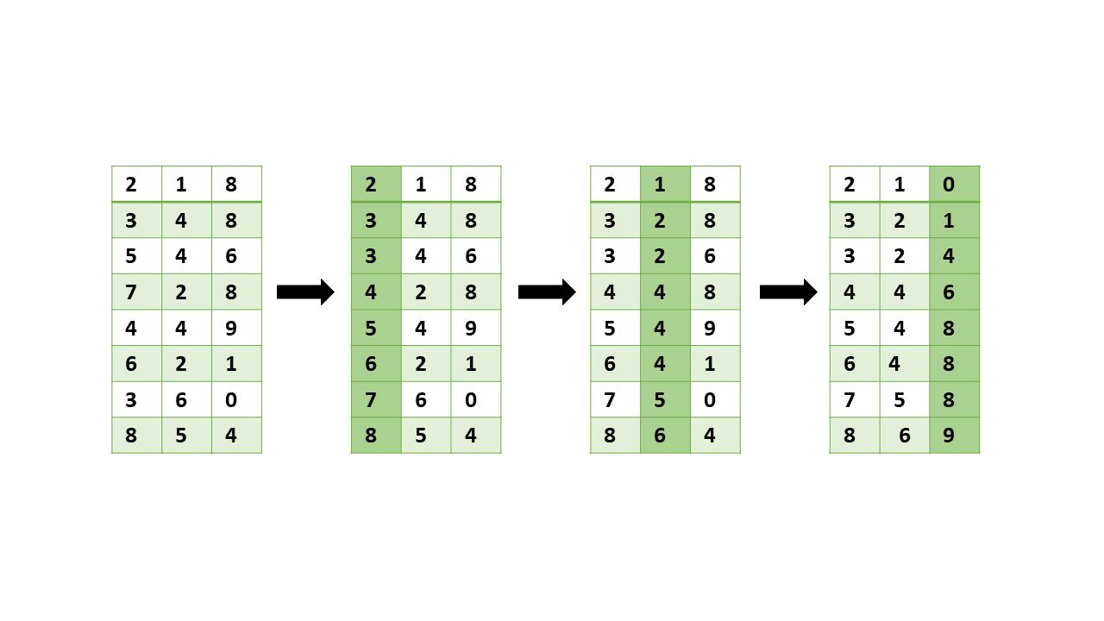
7
TC: O(n + range)
SC: O(range)

🔷 3. HYBRID SORTING
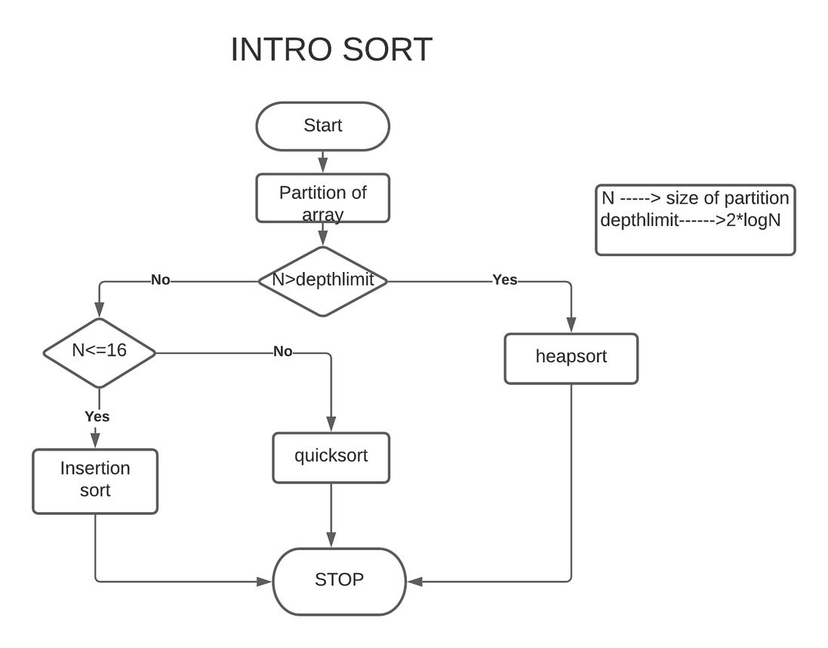
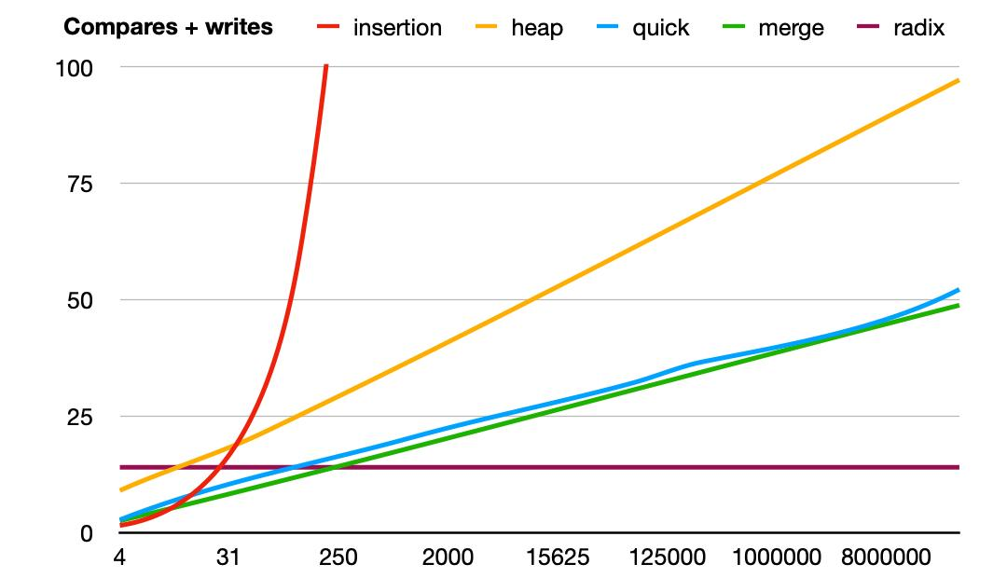
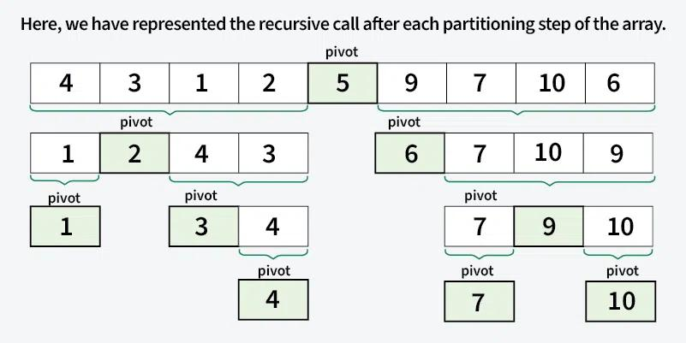
6

🔹 IntroSort
Definition: Quick + Heap + Insertion
TC: O(n log n)
SC: O(log n)
Pros: Avoids worst-case
Cons: Complex

🔹 TimSort
Definition: Merge + Insertion
TC:
- Best: O(n)
- Worst: O(n log n)
SC: O(n)
Pros:
- Very efficient
- Stable
Cons:
- Extra memory

⚖️ FINAL QUICK REVISION
Category | Best Algorithms
Small data | Insertion, Bubble
Large data | Merge, Quick
Memory limited | Heap
Integer data | Counting, Radix
Real-world | TimSort

🧠 FINAL TAKEAWAY
- No single algorithm is best for all cases
- Choose based on:
✔ Data size
✔ Memory
✔ Sortedness
✔ Stability

